CONCOMITANT LYMPHOMA AND TUBERCULOSIS IN A PARROT
(TÜRKÇE BAŞLIK YA DA İNGİLİZCE )

Gözde YÜCEL TENEKECİ¹*, Osman KUTSAL²**
¹Ankara University, Faculty of Veterinary Medicine, Department of Pathology, Ankara, Turkey.
ORCİD ………
*gozdeyucel@gmail.com, +905359347810

²Ankara University, Faculty of Veterinary Medicine, Department of Pathology, Ankara, Turkey.
ORCİD ………
**kutsal@veterinary.ankara.edu.tr, +905322800084

Abstract
Neoplasia is an important problem that should not be overlooked in avian species. In addition to tumors, diseases such as tuberculosis may develop when the immune system is suppressed. In this case, lymphoma and productive lung tuberculosis were observed simultaneously in 10 years old, male, grey parrot. After necropsy was performed, specimens were fixed in 10% neutral buffered formalin. Tissues were processed routinely and stained with hematoxylin-eosin and Ziehl-Neelsen Staining for acid-fast bacilli detection. Microscopically, atypical neoplastic lymphoid cells were seen in spleen and liver and a granulomatous tubercle was detected in the lung. Concomitant tuberculosis and lymphoma is a rare occurrence in parrots that may be due to the immunosuppression of the animal.
Keywords: avian, lymphoma, pathomorphology, tuberculosis

Özet ( Bildiriniz Türkçe ise Özeti ilk sonra Abstarctı (İngilizce) 2. Sıraya yazınız )
Neoplasia is an important problem that should not be overlooked in avian species. In addition to tumors, diseases such as tuberculosis may develop when the immune system is suppressed. In this case, lymphoma and productive lung tuberculosis were observed simultaneously in 10 years old, male, grey parrot. After necropsy was performed, specimens were fixed in 10% neutral buffered formalin. Tissues were processed routinely and stained with hematoxylin-eosin and Ziehl-Neelsen Staining for acid-fast bacilli detection. Microscopically, atypical neoplastic lymphoid cells were seen in spleen and liver and a granulomatous tubercle was detected in the lung. Concomitant tuberculosis and lymphoma is a rare occurrence in parrots that may be due to the immunosuppression of the animal.
Anahtar Kelimeler : …………….

INTRODUCTION
A wide variety of neoplastic diseases are seen in avian species. Especially pet birds like parrots suffer from neoplastic diseases. Lymphoma is one of the most common neoplasms in psittacines and passerines (Leach, 1992; Coleman, 1995; Schmidt and Quesenberry, 1997). On the other hand, when considering lymphoma in all poultry, it should not be forgotten that many types of lymphoma occur as a result of viral infections like Marek’s disease and Avian leukosis (Shivaprasad, 2017).
Tuberculosis is a common disease in poultry as well as in mammals. While several mycobacterial species can cause avian tuberculosis, the most common agent is Mycobacterium avium. It causes tubercle fomations in organs such as intestine, liver, spleen. Microscopically, lesions of avian tuberculosis consist of a central necrotic area surrounded by epithelial cells, lymphocytes, multinucleated giant cells and a fibrous capsule. Calcification of the necrosis is rarely seen in avian species. Acid-resistant bacilli are abundant in the central or necrotic area of the tubercle (Fulton and Thoen, 2003; Dhama et al, 2007).
The aim of the study was to examine pathomorphologically this case, in which two important diseases such as lymphoma and tuberculosis were seen at the same time.

MATERIALS AND METHODS
The material of the case was 10 years old, male, grey parrot. It was brought to Ankara Univesity, Faculty of Veterinary Medicine, Department of Pathology for necropsy. After necropsy was performed, specimens were fixed in 10% neutral buffered formalin, processed routinely and embedded in paraffin. Sections (4-5 µm) were stained with haematoxylin and eosin (HE) and examined under light microscope. Also, Ziehl-Neelsen Staining was done for specimens from lung.
RESULTS
Macroscopically, it was noticed that the liver was enlarged and took up quite a lot of space in the body cavity (Figure 1). There were yellowish mottling on the surface of the liver and its edges were blunt. Also, the spleen was enlarged and reached 2 cm diameter. The right lobe of the lung was slightly dirty yellowish in color.
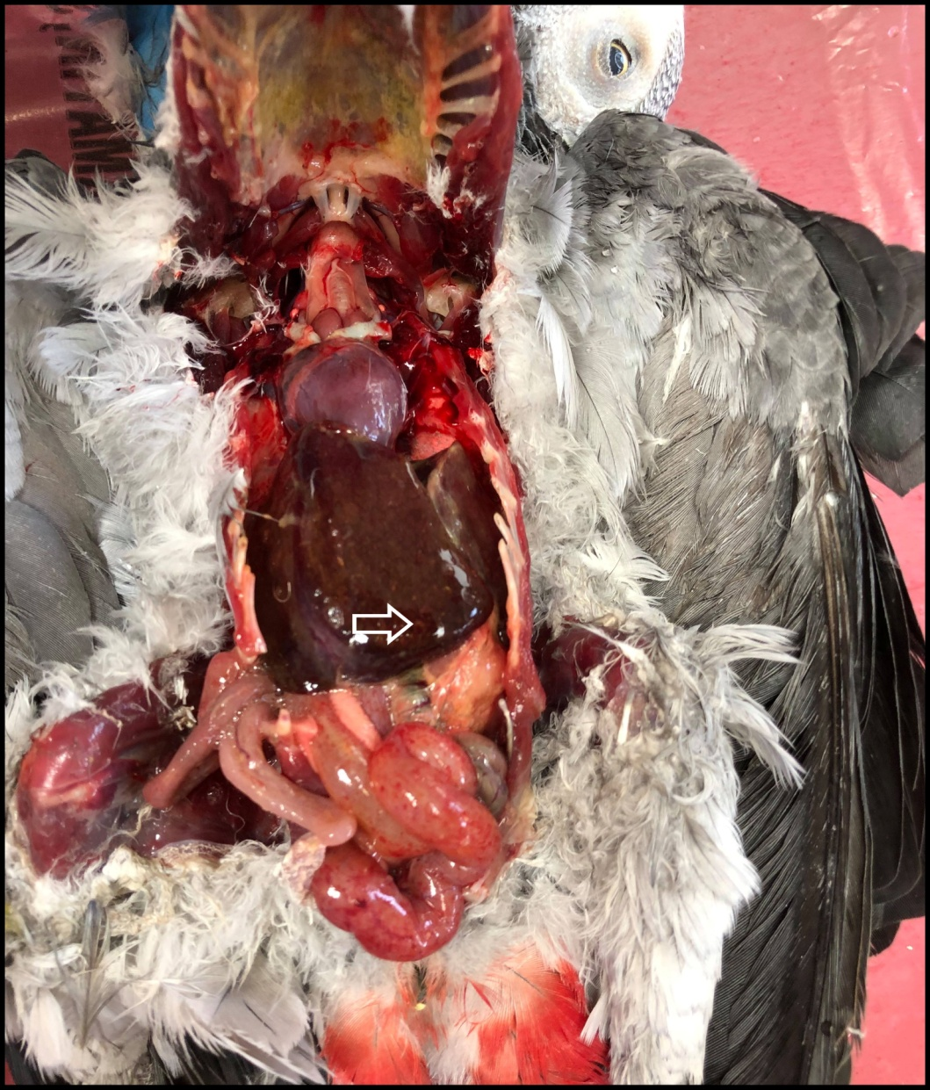
Figure1. Enlargement and yellowish mottling (arrow) on the surface of the liver.

Microscopically, atypical neoplastic lymphoid cells, mostly composed of lymphoblasts, were seen among dissociated cords (Figure 2.a). Degenerative-necrotic changes were observed in most hepatocytes. The same neoplastic cells were also found in the spleen (Figure 2. b). In some areas, it was observed that follicle structures disappeared due to neoplastic cells. In the lung, a tubercle structure formed was seen (Figure 2. c). Neutrophil leukocytes, histiocytes, epithelioid cells, macrophages, lymphocytes and foreign body giant cells was found around the necrosis that located at the center of the tubercle (Figure 2. d). Acid-resistant bacilli were detected with Ziehl-Neelsen Staining.
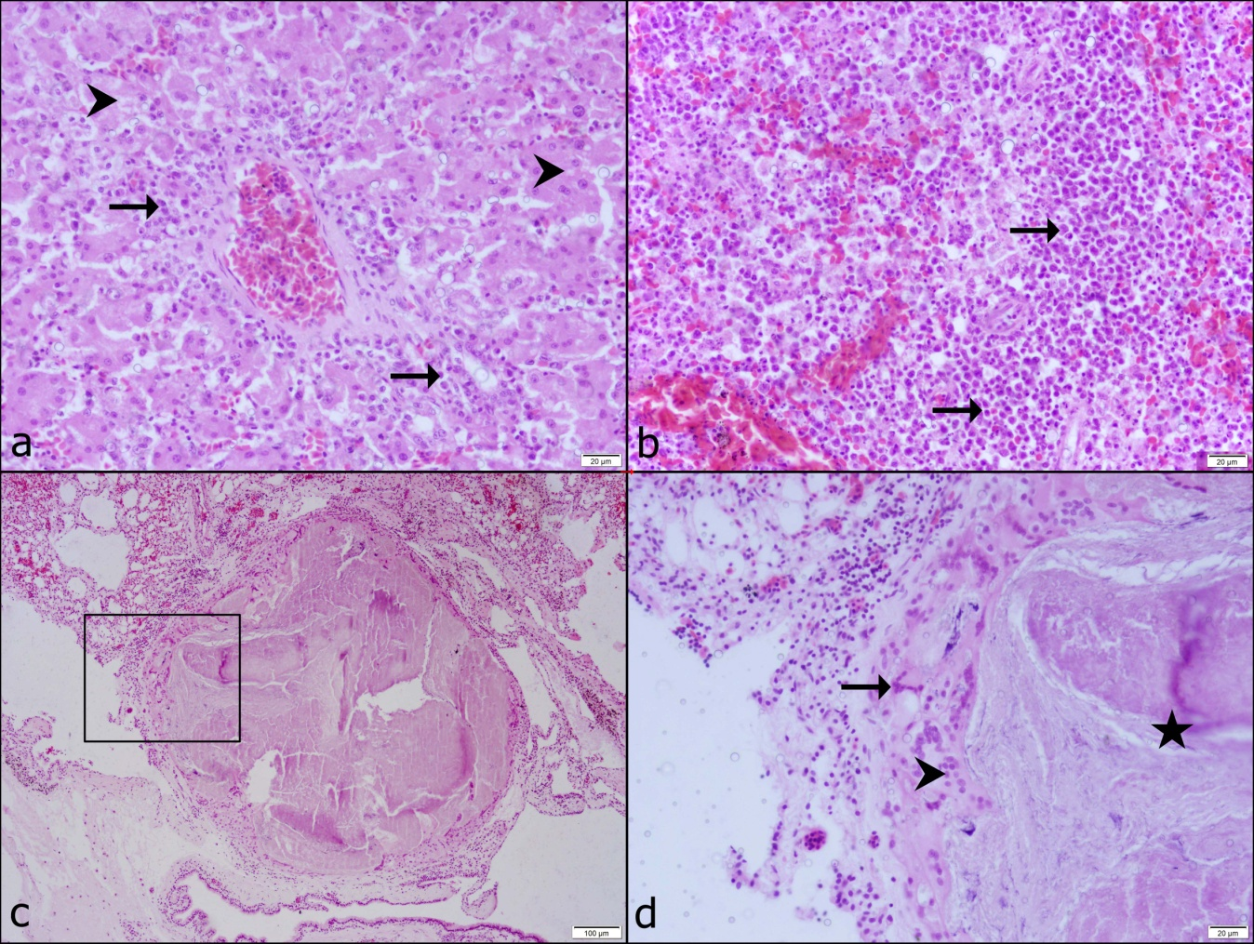
Figure2. a. Atypical lymphoid cells (arrows) between cords and degenerative hepatocytes (arrowheads), liver, HE., b. Atypical lymphoid cells (arrows), spleen, HE., c. Histological appearance of the tubercle formation, lung, HE., d. Closer image of the square in c, necrosis (star), foreign body giant cell (arrow), macrophages and epiteloid cells (arrowhead), lung, HE.

DISCUSSION
In this case, lymphoma, which is reported to be very common in pet birds, was encountered in accordance with the literature (Leach, 1992; Coleman, 1995; Schmidt and Quesenberry, 1997). Enlargement of the organs like liver and spleen is also one of the pathomorphological lesion we expect to be seen in lymphoma cases (Coleman, 1995; Reavill, 2001). So, pathomorphological changes observed in the case were also compatible with the literatures. With this case, considering that lymphoma was seen in a 10-year-old parrot, it was emphasized that the incidence of neoplasia increases with age.
Another finding that we encountered in the same patient incidentally was tuberculosis. It has been reported that tubercle formation in poultry is seen mostly in intestine, liver, spleen, ovaries, testes, and bone marrow. In lungs it is only seen occasionally as in case of tuberculosis of pigions and water fowl (Fulton and Thoen, 2003; Dvorska et al., 2007). In contrast, in this case the tubercle structure was seen in a lung of a parrot. Histologically, in this case, unlike mammalian tuberculosis, the observation of necrosis without calcification and the observation of a foreign body giant cell were consistent with the literature (Fulton and Thoen, 2003; Dhama et al, 2007, Mayahi, 2013).
CONCLUSION
Concomitant lymphoma and tuberculosis has not been reported in a parrot before. We can actually attribute this to the fact that postmortem examination of pet birds such as parrots is not demanded by the owners. Neoplasms generally suppress the immune system, and the possibility of tuberculosis increases when the immune system is suppressed.

REFERENCES
- Coleman CW 1995. Lymphoid neoplasia in pet birds: a review. J Avian Med Surg., 9:3-7.
- Dhama K, Mahendran M, Tomar S 2007. “Avian tuberculosis: an overview,” Poultry Punch, 24 (3): 38–52.
- Dvorska L, Matlova L, Ayele WY, Fischer OA, Amemori T, Weston RT., Pavlik, I 2007. Avian tuberculosis in naturally infected captive water birds of the Ardeideae and Threskiornithidae families studied by serotyping, IS901 RFLP typing, and virulence for poultry. Veterinary microbiology, 119(2-4): 366-374.
- Fulton RM, Thoen CO 2003. “Tuberculosis,” in Diseases of Poultry, Saif YM., Barnes HJ, Glisson JR, Fadly FM, Mc Dougald LR, Swayne DE, Eds, Iowa State University Press, Ames, IA, USA, 836-844 pp.
- Leach MW 1992. “A survey of neoplasia in pet birds,” Seminars in Avian and Exotic Pet Medicine, 1(2): 52-64.
- Mayahi M, Esmaeilzadeh S, Mosavari N 2013. Histopathological study of avian tuberculosis in naturally infected domestic pigeons with Mycobacterium avium subsp. avium. Iranian Journal of Veterinary Science and Technology, 5(1): 45-56.
- Reavill DR 2001. "Pet bird oncology." Proc Annu Conf Assoc Avian Vet. pp.29-43.
- Schmidt RE, Quesenberry K 1997. “Neoplasia. Neoplastic diseases,” in Avian Medicine and Surgery, Altman RB, Clubb SL, Dorrestein GM, Quesenberry K, Eds., WB Saunders, Philadelphia, Pa, USA, 590-60 pp.
- Shivaprasad, HL 2002 "Pathology of birds–an overview." CL Davis Foundation Conference on Gross Morbid Anatomy of Animals, AFIP, Washington DC.

